PROJECT DOCUMENTATION
Title:MCQ Generator with Shuffle
Objective:
To build an AI-powered system that:
- Extracts text from uploaded syllabus PDFs.
- Generates Multiple Choice Questions (MCQs) based on difficulty and count.
- Supports document reuse using stored doc IDs.
- Provides a toggle-based Shuffle feature for generating multiple MCQ sets.
- Enables users to preview and download selected MCQ versions.
Technologies:
- Backend Framework: FastAPI (Python 3.11+)
- Frontend: Streamlit
- LLM API: Google Gemini 1.5 Flash
- PDF Parsing: PyMuPDF (fitz)
- Web Server: Uvicorn
- UI Testing: Swagger UI, Streamlit interface
- Others: os, json, re, random, requests
API Endpoints:
POST /upload-doc - Uploads a PDF and returns a doc_id
GET /documents - Lists all uploaded documents with IDs and filenames
POST /generate-mcqs - Generates MCQs directly from a newly uploaded PDF
POST /generate-mcqs/from-doc - Generates MCQs from previously stored document usi
Working:
1. File Upload:
- User uploads a syllabus-based PDF via Streamlit sidebar or Swagger.
2. Document Selection:
- Users can select from existing uploads using doc_id.
3. MCQ Generation:
- MCQs are generated based on difficulty and question count.
4. Shuffle:
- A 'Shuffle Questions' button allows creating up to 3 randomized versions.
5. Display & Download:
- Original and shuffled versions are displayed below with download option.
Sample Input:
PDF: Biology_Chapter1.pdf
Difficulty: medium
Number of Questions: 5
Sample Output:
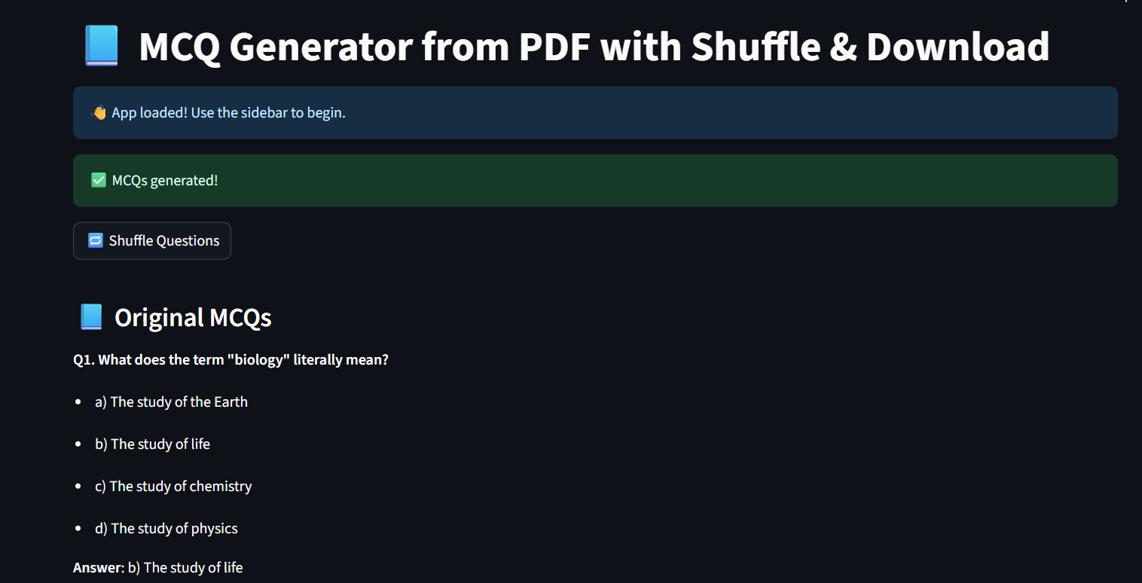
Conclusion:
The MCQ Generator with Shuffle is a practical educational tool that demonstrates how large language models can be integrated with web frameworks to produce intelligent content. It enhances learning, saves manual effort, and provides a clean and flexible user experience through document reuse and randomization features.

